Investors guide for Airbnb business in Crete

In this brief exploration, I'm delving into the Airbnb dataset to offer insights and guidance for potential investors considering property ventures in Crete. Greece's recent policy shift has created an opportunity for international investors to acquire properties in Crete with minimal constraints. Foreign property owners in Greece benefit from rights akin to those of local residents. Consequently, there's a growing interest among investors captivated by the serene beauty of Crete. Whether for business or personal pleasure, like establishing a summer retreat, many are exploring property acquisition. The main objective of this study is to provide a data-driven analysis focusing on individuals contemplating renting out their properties on Airbnb while they are away.

*Note: An interactive dashboard containing all visualizations is attached at the last page for your convenience.*

About the Dataset:

The data utilized for this study was extracted from Inside Airbnb's dataset, a noteworthy open-source initiative by Airbnb. This project employs data to gauge the social, economic, and cultural influences that Airbnb introduces to the communities it operates in. The dataset encompasses various types of information, ranging from geospatial and satisfaction data to demographics and more. To extend the utility of this dataset, the most recent update was conducted on December 27, 2023. For those interested, the dataset can be accessed via the following URL: <http://insideairbnb.com/get-the-data/>

Sampling Methodology:

I employed the equal sampling method to ensure a thorough market overview. It's crucial to recognize that neighborhoods may differ significantly in the number of listings, prompting the use of equal sampling for a balanced representation. After the initial sampling, I revisited the actual number of listings in each neighborhood. This step aimed to delve deeper into the demand trends, acknowledging the inherent variations in popularity and activity across different areas. This meticulous approach provides a nuanced understanding of the market dynamics, offering more accurate insights into the demand patterns for each neighborhood. For specific inquiries or detailed studies and recommendations, please feel free to connect with me on my LinkedIn profile:

https://www.linkedin.com/in/ghassan-hammad-71a70b249/

Locations: Where can I ask for the highest price?

We segmented Crete into 24 municipal regions for a comprehensive comparison. To kick off our exploration, we pose a fundamental question: where are the locations commanding the highest prices on the island?

Regarding the average nightly rental prices, there exists moderate variance across Crete. Topping the list is **Mylopotamos**, standing out prominently with an average of approximately 938 USD per night. Following closely are **Archanon – Asterousion** at an average of 785 USD and **Viannos** at around 723 USD on average.

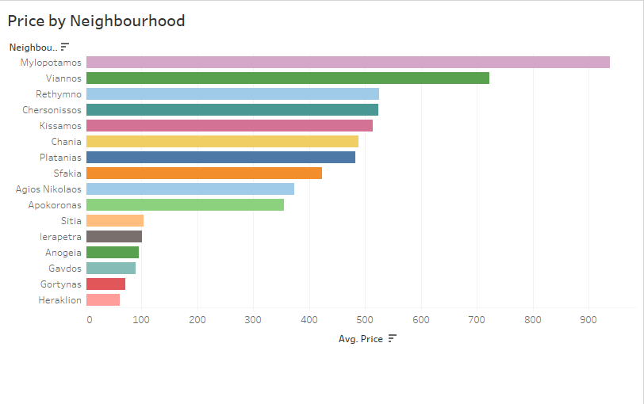

Now, increased profit is consistently a positive indicator of where your investment might thrive. However, the subsequent layer we delve into is the competition – a pivotal factor that significantly impacts property prices, asking rental rates, overall demand, and future ROI trends. We'll delve into these aspects and more in the upcoming section.

Competition by Neighborhood

Leveraging the Pandas library in Python, I extracted the count of listings per neighborhood by identifying the unique listing IDs. I categorized neighborhoods based on their level of competitiveness: highly competitive areas, defined by having more than 1000 listings, and low-competition areas, characterized by having less than 1000 listings.

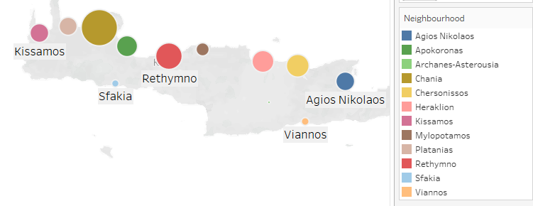I discovered that Chania boasts the highest number of listings, totaling 5666 occurrences, followed by Rethymno with 2954, and then Chersonissos with 2127. It's evident that the northern coast of the island holds the majority of listings, signaling a higher demand for apartments in that geographical area and consequently, increased competition. As a result, these neighborhoods are less recommended for property purchase due to the abundance of available options.

Conversely, Mylopotamos, with the highest price per night, has a lower number of listings, specifically 645 occurrences. This suggests exceptionally high demand, as customers are willing to pay a premium, and the level of competition is relatively lower. Consequently, Mylopotamos stands out as a prime location for property investment. However, given these circumstances, one can anticipate higher property prices in this area.

Vianos, ranking second in terms of the highest willingness to pay, exhibits minimal competition with only 192 listings in the municipal area. It is strongly recommended for property purchase.

In contrast, Rethymno, Chersonissos, Kissamos, Chania, Platanias, Agio Nikolaos, and Apokornas offer a decent price per night but are considered highly competitive areas.

Among the top 10 highest-priced neighborhoods with low competition are Mylopotamos, Vianos, and Sfakia.

Analyzing the number of listings and demand involves considering two crucial factors:

1) More listings in an area indicate higher overall competition. Therefore, identifying neighborhoods with fewer listings implies fewer apartments for customers to choose from, translating to greater value for our property.

2) The number of listings can serve as a measure of demand trends in a particular area. Higher listings suggest increased visitor traffic, indicative of overall demand.

Considering these factors, the key analysis revolves around the initial factor – price or, in simpler terms, the customer's willingness to pay. In summary, the most valuable properties are those with the highest willingness to pay (price) and the lowest number of listings.

To clearly categorize, I opted to feature only the highest-priced 30% of areas. It's worth noting, however, that the contenders towards the bottom of the list have minimal variance. Consequently, I chose to include all three of them.

WTP Vs. Competition: A demand analysis

Employing a heatmap allows us to distill the pivotal factors when scrutinizing demand. The number of listings in a neighborhood signifies heightened demand on one side, yet on the flip side, it also signals intensified competition, potentially resulting in a decrease in prices. The challenge then becomes how to accurately gauge demand.

Our focus narrows down to neighborhoods where the willingness to pay (reflected in the price per night) is substantial and yet the number of listings is relatively modest. This dual criterion signifies heightened demand from customers and a certain level of stability against market trends, at least in the foreseeable future.

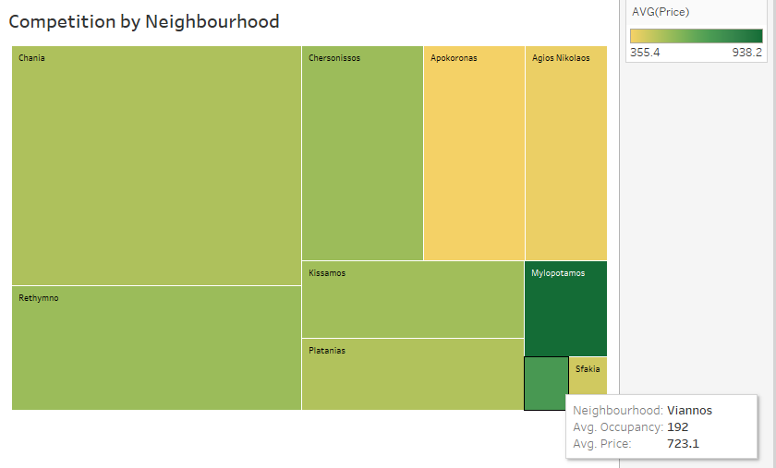Utilizing a heatmap allows us to distill the most crucial factors in our demand analysis. The number of listings in a specific neighborhood signals increased demand on one side, but concurrently, it implies heightened competition, which may result in an anticipated decrease in prices. The challenge lies in effectively measuring this demand.

Our focus zeroes in on neighborhoods where the willingness to pay (reflected in the price per night) is substantial and the number of listings is comparatively modest. This dual criterion indicates elevated demand from customers and a degree of stability against market trends, particularly in the near future.

In our heatmap, the colormap serves to illustrate the price per night, while the square's size represents the number of listings. Notably, the less favorable choices are the larger squares with lighter colors.

.

Observations from the analysis:

1) The neighborhoods with the least willingness to pay, such as Apokoronas and Agios Nikolas, might not be immediately attractive to profit-driven analysts. However, it's crucial to note that these areas, despite having lower willingness to pay, don't exhibit the highest number of listings. This suggests a more nuanced consideration for investment decisions.

2) Chania, Platanias, and Sfakia show similar willingness to pay, but when factoring in the number of listings, Chania emerges as a less favorable investment option. Therefore, for this price range, it's advisable to consider buying properties in either Platanias or Sfakia, with Sfakia being the preferred choice. It's important to note the significant variance in square sizes within this group, indicating potential instability in price and competition trends. The recommendation for Sfakia comes with the caveat that time is a critical factor – investing now might be more favorable.

3) In the mid-price range, Rethymno, Chersonissos, and Kissamos compete closely. Despite similar willingness to pay and number of listings, Kissamos stands out as the recommended investment due to its almost half number of listings compared to the other two. The variance in this group suggests a balanced and more stable future in terms of price and demand trends.

4) The highest-priced neighborhoods, Mylopotamos and Viannos, exhibit the highest demand, measured by high willingness to pay and a low number of listings. Therefore, these areas are highly recommended for investment.

In summary, as of this study, the most recommended areas for investment are Mylopotamos, Viannos, Kissamos, and Sfakia.

Popularity vs minimum number of nights

Considering that the primary audience for this analysis comprises international investors, long-term rentals emerge as a more stable and manageable approach to property management. While Airbnb offers the potential for higher nightly rates, it involves a more dynamic form of renting, providing investors with increased freedom and flexibility with their properties. In this section, I aim to gauge the popularity of an apartment as an indicator of its market performance, measured by the number of reviews. Additionally, I will explore any potential correlation with the minimum number of nights, a crucial factor from the client's perspective, offering them flexibility during their travels.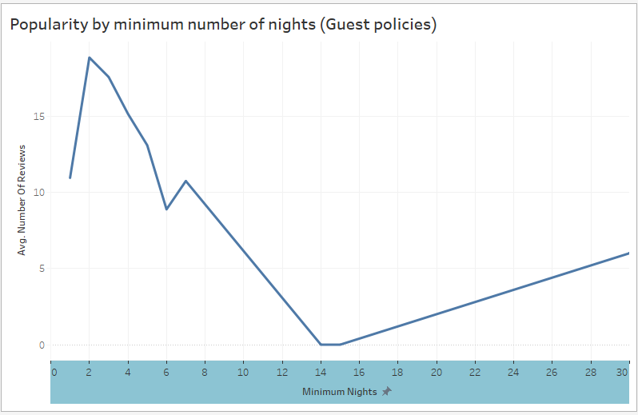

Examining the line chart, a clear trend emerges: listings with a minimum of 2 nights showcase the highest popularity, while apartment popularity tends to decrease as the minimum number of nights increases. This underscores the significance of the guest policy set by the property owner as a crucial factor influencing the popularity of their listing.

For investors, this insight prompts consideration of the minimum number of nights in their property policies. While some may lean towards longer minimum stays, driven by the potential for increased revenue and reduced cleaning and maintenance costs for shorter-term stays, the data suggests that, for enhanced popularity, it might be beneficial to reduce the minimum number of nights. A viable strategy could involve compensating for this flexibility by implementing a cleaning fee for clients. This approach aligns with the observed trend in guest preferences and can be a key factor in optimizing the performance of the property in the market.

**Conclusions:**

**1. High Willingness to Pay vs. Number of Listings:**

- Neighborhoods with high willingness to pay (nightly price) and a lower number of listings are more likely to yield profitable investments.

**2. Competitiveness and Pricing:**

- High competition in a neighborhood may lead to lower prices, making it less favorable for property purchase.

**3. Investment Timing:**

- Timing is crucial, especially for neighborhoods like Sfakia, where current conditions may be favorable, but future market trends could bring increased competition.

**4. Long-Term vs. Short-Term Rentals:**

- Long-term rentals are recommended for international investors seeking stability and ease in property management, whereas short-term rentals through platforms like Airbnb offer more dynamic but potentially more challenging management.

**5. Popularity and Minimum Nights:**

- Apartments with a minimum of 2 nights tend to be more popular. Property owners can consider adjusting their minimum nights policy to enhance listing popularity.

Recommendations:

**1. Preferred Investment Areas:**

- Recommended areas for investment, considering high willingness to pay and lower competition, include Mylopotamos, Viannos, Kissamos, and Sfakia.

**2. Adjusting Minimum Nights:**

- Investors may benefit from reducing the minimum number of nights for increased popularity. Charging a cleaning fee for shorter stays could compensate for potential costs.

**3. Consideration of Neighborhood Dynamics:**

- Neighborhood dynamics, including competition and price trends, should be carefully analyzed before making investment decisions

**4. Long-Term Rental Strategy:**

- For international investors seeking stability, long-term rentals are a prudent option, offering a less strenuous way of managing property.

**5. Continuous Monitoring:**

- Given the dynamic nature of the short-term rental market, continuous monitoring of trends and adapting strategies accordingly is recommended for sustained success.

By considering these conclusions and recommendations, investors can make informed decisions aligned with their objectives and market conditions.

**Dashboard**:

https://public.tableau.com/authoring/CreteInvestorGuideDashboard/Dashboard1#1